|  |  |  |
| --- | --- | --- |
| **LAB 321Assignment** | **Type:** | **ShortAssignment** |
| **Code:** | **J3.L.P0067** |
| **LOC:** | **150** |
| **Slot(s):** | **10** |

**Title:** Dishes Management

**Background**

Restaurant provide services that customer can order a party online. The restaurant also has promotion programs

**Program Specifications**

Program a web site display list of dishes and a page that allow a user to add new a dish

**Features:**

This website contains following main functions

* Function 1: Search Dishes
  + The list of dishes will be displayed
  + The dishes list must be paging
* Function 2: Add New Dish
* Function 3: Edit Dish Details

Database description

* Database must contain promotion detail information displayed on the screen

***Expectation of User interface:***

**PIC 1: List Dishes**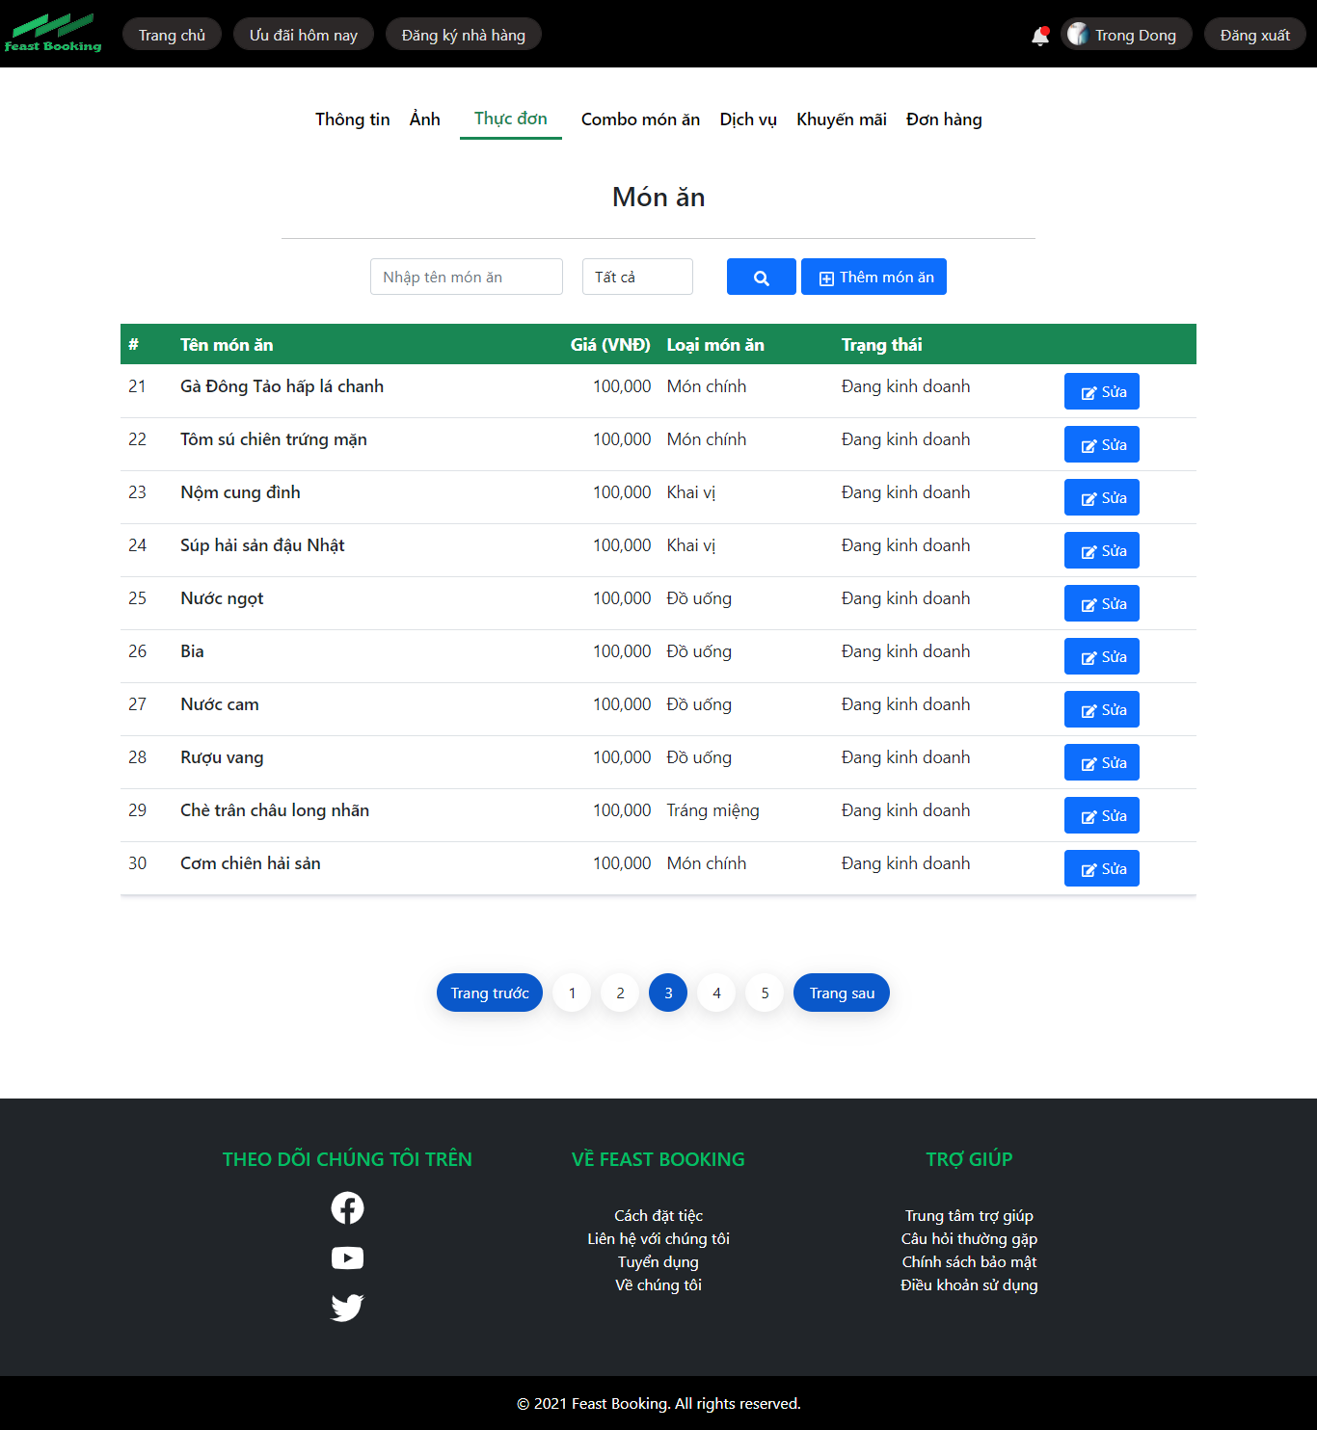

**Note: The following fields must be displayed**

1. Dish Name
2. Dish Value
3. Dish Category
4. Status
5. Previous/Next button
6. Edit button : When user click on “Edit” button, the system will display the Edit **Dish** like page as P**IC03**
7. Add Dish button: When the user click on “Add Dish” button the system will display the Add New **Dish** page as P**IC02**

**PIC 2: Add Dishes**

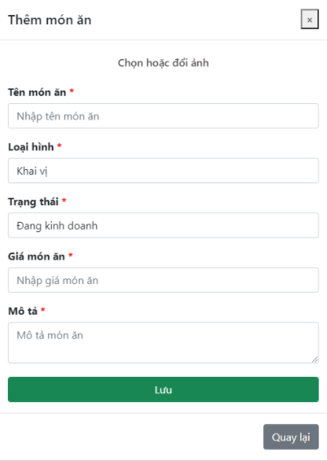

**Note: The following fields must be displayed**

1. All fields in the screen must be got from database
2. When user click on “Back”, the dishes list will be displayed
3. When user click on “Save”, the dishes list will be displayed

**PIC 3: Edit Dishes Info**

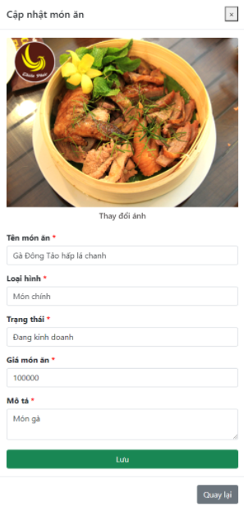

**Guidelines**

* Step 1 : Create web layout
* Step 2 : Create prototype
* Step 3 : Design database base on created prototype
* Step 4 : Code & Test